Parabola is a curve of infinite extent and is not often obsened in real life as circles or shaight line are . However, the parabplaic curres are very important and have some vert good propertvies like the light raus reflected from parabolic surface passes through one foxed point. This property of parabola is luidely used in making lenses and in optics.
The brridges also take parabolic shape have been centuries lod. So, now let us start studying this interesting curre in more detail.
Parabola is locus of point which moves such that its distance from fixed point (focus) is always equat to its distance from fixed line (directrix) i.e. eccentricity, e = 1 .
Note: The distance from fixed point to the distance from fixed line is calle
General second degree equation: eccentncity.
The equation ax² by + 2hxy + 2gx + 2fy + c = 0
(1) Second degrel thrms make a perfict square. or n ² = ab.
Why ?
Let the fixed point be . and fixed line ax + by + 1 = 0 Let variable point be (h,k).
Now,according to the definition of parabola.
the distance of (h,K) from () is same as distance from line ax + by + 1 = 0.
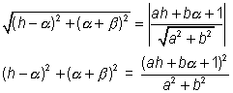
So locus of 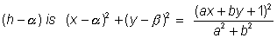
On simplification, we get
(a² + b²)=(ax + by + 1)²
The expression reduces to
b² x ² + a² y² - 2abxy + .....linear terms .... + conjtant=(bx - ay)² + ......linear terms + constant = 0.
So, second deqree terms make perfect squarc.
Dumb Question: Why is h²= ab same as second term making a perfect squarc ?
Ans The second degree terms in equation are
ax² + by²+ 2hxy .
Now if h² = ab
then
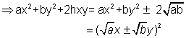
So, the two thing are same .
(2) 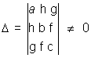
Illustration 1
Ide ntify the locus of point which move such that its distance from given point and line is equal ?
(i) (-3,7) is the point and x + 2y - 8 = 0 is given line .
Ans Now according to the question, let the point whose locus is to be determined be (x,y).
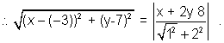
or,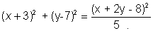
=>. 5 (x² + 9 + bx + y² + 49 -14y)
= x²4y² + 64 -16 x - 32y +4xy
= 4x² + y² - 4xy + 46x - 38y + 226 = 0
Considening 2⁰ term, 4x² y² - 4xy = (2x - y)² which is a perfect square.
Now consider
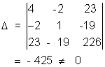
So, the locus is a parabola
(ii) (-6,7) is point and x + 2y - 8 = 0 is given line .
Ans. Note taht (- 6,7) satisfies the given line .
So, the locus is stratight line itself .
Standared Equation of parabola.
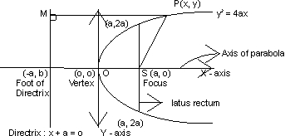
Important properties
(i) Vertex 0 (0,0)
(ii) Focus s(9,0)
(iii) Foot of directrix (-9,0)
(iv) Directrix x + a = 0
(v) Equation of catus rectum x = a
and length of Latus retum = 4a .
(vi) Axis y= 0.
(vii) Extremiofies of latus retum (9₁ 2a) & (9₁-2a)
Note : Two parabolas are said to be equal if their length of latus rectii are equal
Types of parabola
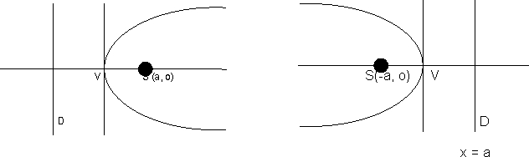
x + a = 0 y² = 4ax, a > 0 Y² = - 4ax, a > 0
s
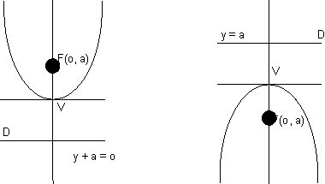
Transformation of parabola.
(a) (y - R)² = 4a (x - h) , a > 0
The vcetex will be (h , k), openitng of parabola will be on = ve side of axis, axis will be || to x axis and dire ctrox well be || to y axis.
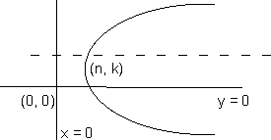
(b) (y - R²) = 4a (x-h), a < 0
Same as above except, the opening of parabolanwill be on -ve side of x - axis .
s 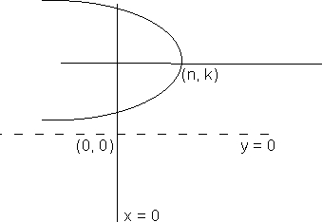
(c) (x -h ²) = 4a (y - yR), a > 0
The vertex will be at (h,K) opening of parabola will be on +ve side of yaxis , axis will be || t y - axid and directrix || to x - axis
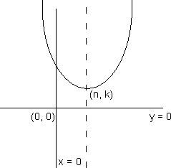
(d) (x -h ²) = 4a (y-K), a < 0
Same ad above except, lthe opening of parabola will be on -ve side of y-axis .
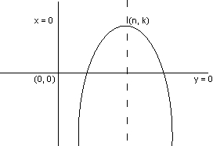
Illustration 2.
Find the vertex, axis, focus, and latus rectum of parabola
4y²+ 12x -x - 20y + 67 = 0
Ans The equation can be written as
y²- 5y = - 3x - 67/4 .
i.e. (y-5/2²) = - 3x - 64/2 + 25/4 .
= - 3(x + 7/2)
So, this a transformed parabola whose vertex is (-7/2, 5/2), the axis is y = 5/2.
The length of latus rectum = |4a| = 3
and a = -3/4 .
So, focis is (-7/2 - 3/4 1 5/52)
= (-17/4 1 5/2).
Natations :
For standard parabola (y² = 4ax)
1) Sy²- 4ax
2) S₁y ₁²- 4ax₁
3) Tyy₁-2a(x + x₁)
4) F(at ,² 2at)
Position of a point (x₁,y₁) w. r. t y² = 4ax
If S₁ > 0 => Outside parabola.
S₁ < 0 => Inside parabola.
S₁ 0 => On parabola.
Why ?
Suppose a point is outside parabola .
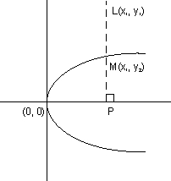
s So, PL > PM.
=> PL ² PM²
or y₁² > y₂²
or y₁² > 4ax₁( M lics oh parabola).
So, S₁ > 0 => Point is outside parabola .
Similarily when point is inside the parabola .
S₁ < 0 .
Dumb Question:- What dose inside and outside the parabola mean in a curre like parabola which is not closed ?
Ans :- the wird "outside" refers to the region from where tangent can be drawn . On other hand, the region from where tangent cannot be drawn is fefference as "in side" the parabola.
Par ame tric form.
x = at², y = 2at where t is a parameter represents the parametric form.
(at², 2at) is general point on parabola y² = 4ax .
Illustration 2.
Find the equations of the parabola if the extremeties of its latus ractum are (3,5) and (3,7).
Ans.
Now the length of latus ractuin is
So, 4a = 2 or a = 1/2 .
Now middle point of catus ractum is
(3+3/2, 5+7/2) = (3,6) which is focus of parabola.
So the two cases as shown in figure below are possible.
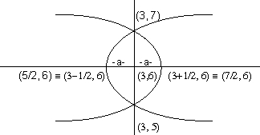
Since the vertex is at a distance a away from the parabola the vertices are (7/2, 6) and (5/2,6).
Now lBy transformation of parabolas the two parabolas possible are
(y-6)² = 4(1/2) (x-5/2)
& (y-6)² = 4(1/2) (x-7/2).
So, equation of parabolas are
(y-6)² = 2 (x-5/2)
& (y-6)² =2 (x-7/2)
Dumb Question . Why two aprabolas are possible ?
Ans In this question only lasus ractum is given and two parabola are possible having same latus ractum on either side as shown in figure
Tangents to a parabola :
Let us find equation of tangents to parabola y² = 4ax
(i)Equation of tangent of slope m : -
y = mx + a/m
And, the point of contact is p = (a/m², 2a/m)
Why ?
Let line y = mx + c . be tangent to parabola y ² = 4ax.
Saluing the two curres tom gether.
We get, (mx + c)² = 4ax .
Since the line is tangent, this equation will have repeated roots.
So, D = O.
Now, (mx)² + (2mc - 4a) x + c² = 0
is equation.
D = 4 (mc-2a)² - 4m² c ² = 0
=, (mc - 2a)² - m²c² = 0
=, (mc - 2a - mc)(mc - 2a + mc) = 0
=| - 4a (mc - a) = 0
=, c = a/m
(ii) Equation of tangent at (x₁,y₁)
yy₁ = 2a (x+x₁)
Why?
Now y² = 4ax .
so, dy/dx = 2a/y
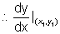= is slope of tangent at (x₁,y ₁)
So,
Put m - 2a / y₁ in equation y = mx + a/m
=> y = 2a/y₁ x + ay₁/2a
=> yy₁ = 2ax + 4ax₁/2
(iii) Equation of tangent at (at ², 2at)
ty = x + at²
Why ?
Put x₁ = at ²| y₁ = 2at in
Equation yy₁ = 2a (x + x1)
=> (2at) ly = 2a (x + at)²
= ty = x + at²
Illustation 4.
Prove that line x + my + am² = 0 touches the parabola y ² = 4ax. Also find or dinates of point of contact .
Ans:- Solving, parabola y² = 4ax with line
x + my + am² = 0, we get
y² 4a (-my - am²)
or. y ² + 4amy + 4a²m² = 0
or. (y + 2am)² = 0 .
Since above is a perfect square, therefore both the values of y are equal. Hence given line is tangent to parabola and ordinates of the point to contact is - 2am (from y - 2am = 0)
Ptting, value of m in equation of the line we get x = am².
Hence point of contact is (am², - 2am)
Illustration 5
Find equation of straught lines touching both x²+ y² = 2a² and y² = 8a
Ans:- the parabola is y² = 8ax
or y² = 4 (2a) x .
So, equation of tangent is
y = mx + 2a/m
or. m²x - lmy + 2a = 0
Since this is tan gent to x² + y² = 2a², So the length of perpendicular from (0,0) must be equal to the radius ie
or 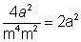
=> m⁴ + m² - 2 = 0
=> (m²+2)(m²-1) = 0
=> m²-1 = 0
=>
So, the equired tangent is
Equation of pair of tangents.
The equation of pair of tangent from (x₁,y ₁) is
t² = ss₁
or. (yy₁- 2a(x + x₁))² = (y² - 4ax)(y₁² - 4ax¹)
Why ?
Let p(x₁1 y₁) be point from which tangents is drawin to y² = 4ax
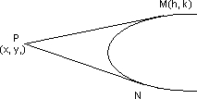
Let m(h₁R) be any point on either of tangent of straight line joining p and M is
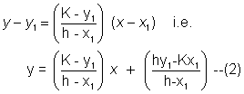
As this is tangent to given parabola, it should be of the form.
y = mx + a/m .-------(3)
Comparing (2) and (3) we get
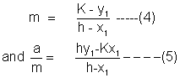
Eliminating M from equation(4) and (5) we get .
=> a(h - x₁)² = (K-y₁)(hy₁- K x₁)
Putting (x₁y₁) in place of (h₁K) gibes equation of locus of M. as
a(x - x₁)₂ = (y - y₁)(xy₁ - yx₁)
Which on rearranging gives .
Illustration 6.
Find the equation of tangents drawn to y² + 12x = 0from point (3,8).
Ans Now, y² = - 12x
or 4a = - 12
=> a = - 3
On . Comparing with standard form of tangent to parabola should be
y = mx + a/m or y = mx -3/m
Since tangent passes through (3,8) we ha
8 = 3m -3/m
or. 3mm² - 8m -3 = 0
or (m - 3) (3m+1) = 0
=> m = 3, -1/3
Hence there _{L} two tangents tnrough point (3,8)which are
3x - y -1 = 0
& x + 3y -27 = 0
Dumb Question Why tangent was taken in the form y = mx + a/m .?
Ans Whenever we have to take tangent from a point lying outside the parabola it is preferabee to take equation in this form as it is left second by satistying given opoint in the equation.
Normal to a parabola.
(1) Equation of normal at point (t)
y = -tx +2at +at³
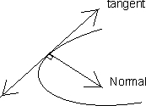
Why?
Slope of normal at (at², 2at)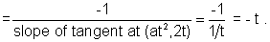
Equation of normal at (at²,2at) is y - 2at = - t (x-at²)
or y = - tx + 2at + at³
(2) Equation of normal slope m
Putting m = - t in above equation
y = mx - 2am - am³ (3) Equation of normal at (x₁,y₁)
y-y₁= -y₁/2a (x - x₁)
Some important point .
(1) Maximum 3 normals can be drawn from anyn piont (h₁K ) to parabola y² = 4ax .
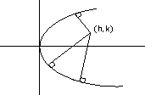
Why?
Equation of normal is
y = - tx + 2at + at³
So, 3 different value of t are possible when we put (h₁ K) in given eqquation
i.r K = - t(n) + 2at + at³
Hence, 3different normals are possing .
(2) Three distirnt normals can be drawn from point (h₁ K ) to parabola y₂4qx iff 4 > 2a .
Illustration 7.
Three normal to y² = 4x pass through point (15,12) Show that one the normal is given by y =x - -3 and find equation of the others.
Ans:- y² = 4x .
=> 4a =4 ie a = 1.
Any normal to parabola is
y = mx - 2am - am³
putting a= 1 , we get
y = mx - 2am - am³
As it passses through (15,12) we get
12 = 15m - 2m - m³
or m³ - 13m + 12 = 0
or (m - 1) (m + 4) (m - 3) = 0
m = 1, 3; - 4.
Hence three naormals are
y = x - 3
y = -4x + 72
y = 3x - 33.
Dumb Question. How was m³ - 13m + 12 = 0
factorized into (m - 1) (m + 4)(m - 3) = 0. ?
Ans:- It was given in the question kthat it is to lbe shown that y = x - 3 is nirmal .
So, m = 1 should be factor of m³- 13m + 12 = 0 which it is.
Hence m³- 13 + 12 = 0 is written as
(m -1 ) (m² + m - 12 ) = 0
or (m -1) (m + 4) (m - 3) = 0
Chord of contact .
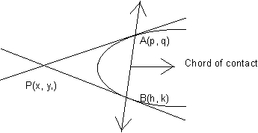
Equation of chord of contact: -
T 0
or yy₁ - 2a (x + x) = 0.
Why ?
Let point p(x₁, y₁) be
A (p₁q ) and B (h₁K ) on the parabola.
Equation of PB is lKy - 2a(x + h) = 0
Both these stangents pass through p(x + x₁)
9y₁ = 2a (x₁ + p)
and Ky₁= 2a (x ₁ + h)
Now consiedr equation yy₁ - 2a (x + x₁ ) = 0
This equation is of first degree in x & y and it represcnts straight lline passing through
A (p₁q ) and B (h₁K )
Hence, equation yy₁- 2a (x + x₁) = 0
represents equation of line A B which is called chord of contact of point (x₁1y ₁)
Illustration 8.
From point (- 1, 2) tangent line are drawn to parabola y² = 4ax. find equation of hord of contact . Also find area of triangle formed by hoed of contac and the tangents.
Ans. Chord of lcontact of 0(-1,2) is
yy₁ = 2a (x + x₁)
or y = x - 1
Solving with parabola y = ² 4x we get the points
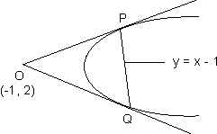
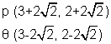
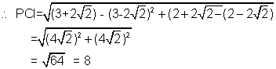
The distance of point 0(-1, 2)from line y = x -1 (Chord of contact) is
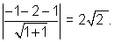
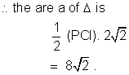
Chord of mid point ( x₁,y₁)
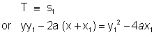
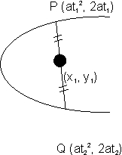
Note: Only one such chord is possible .
Why?
Any line through point (x₁, y₁) is
(y - y₁) = m(x - x₁ ----(1)
Now wehave to derermine value of m₁ its slope.
If it meets parabolain P( at₁, 2at₁ )and
then its equation is
y(t₁ + t₂) - 2x - 2at₁t₂ = 0 ----(2)
So, by companing slopes in (1) and (2) we get
Since (x₁,y₁) is mid point of
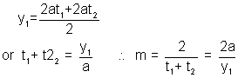
Putting 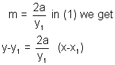
On reamanging, we get
yy₁ - 2a(x + x₁) = y₁² - 4ax₁
or
Eauation of chord.
(i) Equation of chord joing (x₁),y₁) and (x₂, y₂) is
y(y₁ + y₂) = 4ax + y₁y₂
(ii)Equation of chard joing (at₁², 2at₂) and(at₁², 2at₂) is
y(t₁ + t₂) = 2 (x + at₁ t₂)
Note that both these results can be obtained by finding the middle point of the line joinign the two points and then using chord with mid point equation.
Illustration 9.
Show that locus of mid point of any focal chord is y² = 2ax - 2a²
Ans Let the mid point be (h₁K)
So, the equation of this kchord is
i.e yK - 2a (x+h) = K² - 4ah.
Now this chord is focal chord, si it must pass through (9,0).
=> (9,0) must satisty
yk -2a (x+h) = K² - 4aK
or . 0 - 2a(a + h) = k² - 4ah
or k² - 2ah + 2a² = 0
Locus is y²2ax + 2a² = 0
or y² = 2ax - 2a².
Diamcter
Thelocus of middle point of a system of || chords of a parabola is called a diamcter .
If y = mx + c represents a system of | | chord of parabola y² = 4ax, then likne y = 2a/m is equation of diamcter and this will meet parabola at 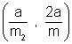
Why?
The chords y = mx + c where c varies infersed the parabola y² = 4ax at point y₁ and y₁
Now, y' and y" are roots of equation
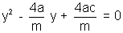
Which is obtained by solving y = mx + c
With y²= 4ax .
Equation is Let the middle point of the chords be (h,k)
So, 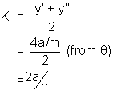
The equation of diametcr is y = 2a/m
llustration 10.
The general equation to a system of parrallel chords in parabola 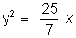is 4x - y + K = 0 . What is equation of corresponding diamcter ?
Ans Equation of parabola is y
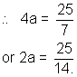
And the equation of system of | | chords
is 4x = y + K = y .
m = 4 .
So, diameetcr 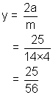
or 56y = 25.
Some Important and useful results
1. Focal distance of a point (at²,2at) is a + at²
Why?
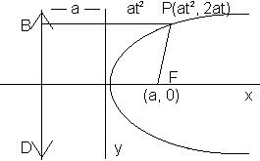
Now focal distance = Pf = PB = a + at²
= a +x,sub>1 (if (s₁, y₁) is point )
2. Foot of perperdicilar drawn from focus of parabola to any tangent will lie on tangent at vertex.
Why?
Equation of tangent is y = mx + a/m ---(1)
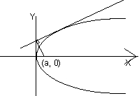
Equation of normal is 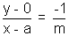
or my + x = a ----(2)
Solving (1) & (2) we get
x = 0, y =a/m .
(O,a/m) is the point and clearly it lies or y - axis
3. The circle descvibed on any focal chord as diamcter touches the directrix of the parabola .
OR.
Any two tangents drawn from point on the directrix to parabola are perpendicular to each other and the chord of contact is focal chord .
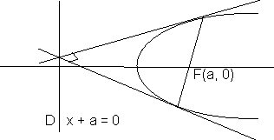
4.) If any focal chord meets parabola at t₁and t₂.
then t₁t₂ = - 1 .
Why ?
Slope of AC = slope of AB
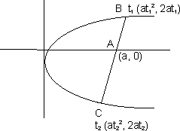
So,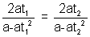
=>t₁(1 - t₂²) = t₂(1 - t₁²)
t₁- t₁t₂(t₂) = t₂ - t₁t₂ (t₁)
(t₁ -t₂) + t₁t₂(t_{1- t2}) = 0
(t₁ -t₂)( 1 + t₁t₂) = 0
=> t₁t₂ = - 1.
Dumb Question Why t₁ - t₂ 0?
Ans If t₁ -t₂ = 0 => t₁ = t₂
So, this will mcan that point B and C are same point which is not true .
Hence t₁ - t₂ 0
5). If any chord joining t₁ and t₂ subtends right angle at vertex that t₁t₂ = - 4 .
Why?
Slope of VA slope of VB = - 1 .
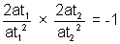
t₁t₂ = - 4 .
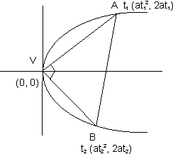
6). Normal at t meets parabola at point (- t -2/t)
Why ?
Normal at t is ly = - tx + 2at + at³
It meets parabola at t¹
t¹ will also satisfy the equation
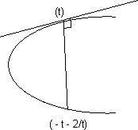
2ar¹ = - t (at'²) + 2at + at³
or t(t'² - t²) + 2 ( t'-t) = 0
or (t'-t) (t(t' + t) + 2) = 0
=> t' = t or t' = - t -2/t
But t' t as lpoint is different . So, t' = - t-2/t
7) If two normals at point t₁ and t₂ meet again on parabola then t₁t₂ = 2 .
Why ?
Now 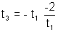(from previous result) and also
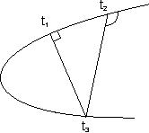
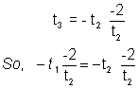
=> t₁t₂ = 2
8) Point of intersection of tangents at t₁ and t₂ is (at₁ t₂ ,a (t₁= t₂)).
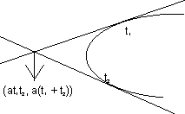
9) Point of intersection of normal drawn at t₁ and t₂ is
[2a + a (t₁²+t₂² + t₁ t₂), - at₁t₂(t₁ + t₂)].
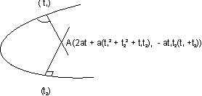
(10) Reflection property of parabola. the tangent (pT) and normal (PN) ofparabola y²=4ax at p are the internal and external bisectors of SPM and Bp is to axis of parabola and BPN=SPN diagram 25
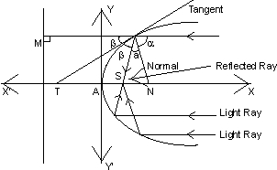
Illustration:
A ray of light coming along line y=b from the positive direction of x-axis strikes a concave mirror whose intersection with x-y plane is a parabola y²= 4ax. Find equation of reflected ray and show it passes through focus of parabola
. both a and b are positive.
Ans:- given parabola is y²=4ax.
Equation of tangent at
diagram26 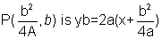
slope of tangent=
hence, slope of normal 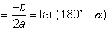
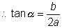
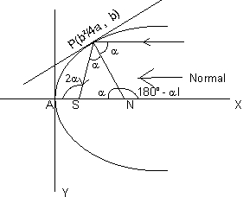
slope of reflected ray
=tan(180-2)
=-tan 2
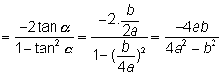
=(y-b)(4a²-b²)=-(4ax-b²)b
which clearly passes through focus s(a,0)
Easy :-
E_1 show that the line xcos +ysin=p
touches the parabola y²
=4ax if p cos+a sin²=0
and that the point of contact is (atan² ,-2atan)
Solution: The given line is
xcos +ysin=p
or y=-xcot+pcosec
m=-cot and c=p cosec
since the given line touches the parabola
c=
or cm=a
or(pcosec)(-cot=a
and point of contact is
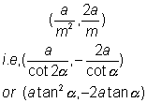
E-2 show that normal to the parabola y₂=8x at the point(2,t) meets
it again t (18,-12). find also the length of the normal chord.
solution-
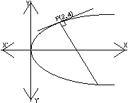
s comparing the given parabola(i.e, y²=8x) with =4ax
4a=8
a=2
since normal at (x1,y1) to the
parabola y²=4ax is
y-y1=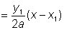
Here x1=2 and y1=4
equation of normal is,
y-4=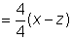
= y-4=-x+z
=y+x-6=0............(1)
diagram solving (1) and y2 =8x
y2=8(6-y)
=y²+8y-48=0
(y+12)(y-4)=0
y=-12 and x=2
hence point of intersection of normal and parabola are(18,-12) and(2,4) therefore
normal meets the parabola at(18,-12)
and length of normal chord is distance between their points
E-3 IF Three distinct and real normals can be drawn to y²=8x from the point (a,0) then show that a>4.
ans:- Equation of normal in terms of m is y=mx-4m-2m³=0
it passes through (a,0) then am-4m-2m³=0
m(a-4-2m2)=0
= m=0, m2=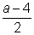
for three distinct normal , (a-4)>0
=a>4
E-4 if y+b=m,(x+a) and y+b=m(x+a) are two tangents to the parabola y²4ax, then show that m1m2=-1
which lies on the directrix x+a=0. hence th etwo tangents intersect on directrix which we know is the locus of perpendicular tangents .
hence m1.m2=-1
E-5 show that the parametric representation (2+t₂,2t+1)
represents a parabola with vertex at (2,1).
Ans:- x=2+t², y=2t+1.
Eliminating t= we get (y-1) ² =4(x-2)
i.e, a parabola with vertex at (2,1).
Ans: Equation of the given parabola can be written as,
9x²+12x+4+18y-18=0
i.e, (3x+2)²=18(y-1)
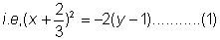
Equation of tangent to the above parabola can be written as-
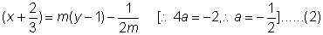
IF the tangent passes through (0,1) then we have,
0.m² -4m-3=0
gives,m=-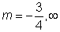
hence equation of the required lines are,
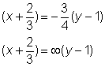
i.e, 12x+9y-1=0
and y-1=0
E-8: the tangents to the parabola y² =4ax at p(at²,2at) and q(at₂²,2at²) intersect at r. prove that the area of the triangle
PQR is 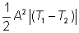
Ans:
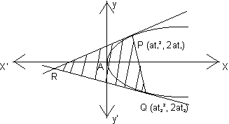
equation of tangents at p(at²,2at1) and Q(at₂²,2at₂)
are, t₁y=x+at1²............(1)
and t₂y=x+at₂²
since point of intersection of (1) and (2) is r(at₁t₂) (at₁t₂,a(t₁+t₂)
E-6 the normals with slopes m1, m2, and m3 are drawn from apoint p not on the axis of the parabola y²
=4ax ifv m1 and m2= results in the locus of p being a part of parabola, find the value of
Ans:
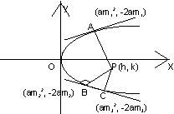
Any normal of the parabola y²=4x with slope m is
y=mz-2m-m³
thus, m1.m2.m3=-k
m₃=-k(m1m2=
= 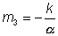
m₃ is aroot of(1) then,
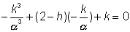
=k3+(2-h)k²-k³=0
locus of p(h,k) is,
y³+(2-x)y²-y³=0
(p does not lie on the axis of the parabola)
=y²=²x-2²+³
it is a part of the parabola y²=4x
then ²=4
and -2²+³=0
=-2=0
=2
E-7: find the equation of aline which touches the parabola
9x²+12x+18y-14=0
and passes through the point (0,1).
AREA OF TRAINGLE: 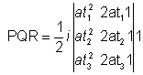.
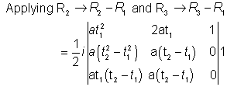
Expanding with respect to first row-
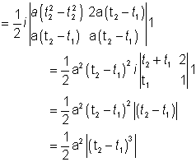.
E-9: Find the length of the normal chord to the parabola y²=4x which substends a right angle
at the vertex Ans:- a=1 for parabola PQ being normal chord.
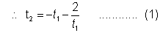
PQ substend a right angle at vertex,
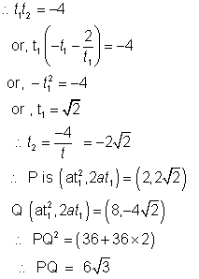
E - 10. An equilateral triangle SAB is inscribed in the parabola y2 = 4ax Having its focus at 'S'.
It chord AB lies towards the left of S. Then find the side length of this triangle.
Ans:
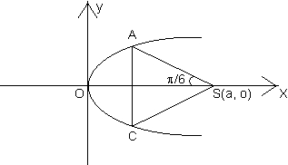
let A=(at₁²,2at₁),B=(at₂²-2at₁)
we have
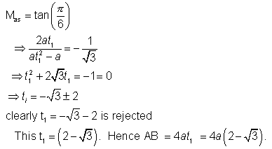
Q� Prove that 9x2 - 24xy + 16y2 - 20x - 15 y -
60 = 0 represents a parabola. Also find its focus and directrix.
Ans: Here h²-ab=(-12)²-9x16=144-144=0 also
the equation represents a parabola Now, the equation is(3x-4y)²=5(4x+3y+12) clearly
, the lines 3x-4y=0 and 4x+3y+12=0 are perpendicular to each other.so, let 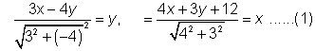
the equation of the parabola becomes -
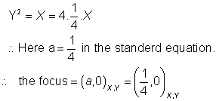
Now if 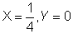
then we havefrom the equations of tranformation in(1)
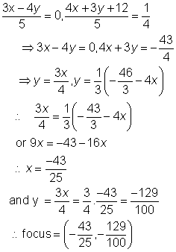
The equation of directrix is,
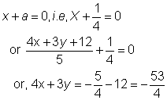
The directrix is 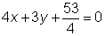
Dump Question: The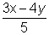 was written as Y and 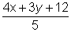was
written as y.how?
Ans: The lines 3x-4y=0 and 4x+3y+12=0 are to each other as clear from
their slopes. so, the rotation of axis and transformation of axes was performed
to get the desired easy form of parabola.
Q.2:- Three normals from a point to the parabola y2 = 4ax meet the axis of the parabola in points whose abscissa
are in A.P. Find the locus of the point. Ans : The equation of any normal to
the parabola is Y = mx - 2am -am3 It passes through the point (h,k) if am³
+ m (2a - h) + k = 0 ??????. (1) the normal cuts the axis of the parabola viz
, y = 0 at point where x = 2a + am2 hence the abscissa of the point in which
the normal through (h,k) meet the axis of the parabola are. X₁ = 2a + am1² , x₂ = 2a + am₂³ , x₃ = 2a + am₃ ² Since X₁ ,x₂, x₃ are in A.P. (2a + am2¹) +( 2a + am2³) = 2 (2a + am2²)
= m₁²+m₂²=2m₂²..........(2)
also from (1) m₁+m₂+m₃=0..............(3)
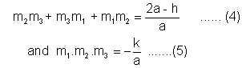
from (3) (m₁+m₂)²=m₂²==m₁²+m₃²+2m₁m₃=m₂²
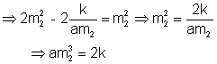
Since m₂ is a root of (1), am₂ ³+m₂(2a-h)+k=0
= 2 k+m ₂ (2a-h) + k = 0
27 ak² = 2 (h - 2a)³
Hence the locus of(h,k) is 27ay²=2(x-2a)³ M-3- prove that the length of the intercept on the normal at the point p(at²,2at) of a parabola
y²=4ax made by the circle on the line joining the focus and point p as diameter is a
ANS: let the normal at p(at²,2at) cut the circle in k and the axis of parabola at g then pk is required intercept.
SP=PM=a+at²
Since angle in a semicircle being right angle .SPR=90.
and normal at p(at²,2at) is
y = - tx+2at+at³
= tx + y - 2at - at³=0
SK is the perpendicular distance from s(a,0) to the normal(1)
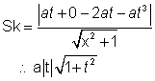
in SPK
(PK)² = (SP)² - (SK)²
= a²(1+t²)² - a²t² (1 + t²)
= a² (1+t²)
Dumb Question:- why is SP=PM in the above question? Ans: the point p lies on the parabola . so the distance of p from directrix is same as the distance from the focus. and hence SP=PM. Q-4:- Three normals are drawn from the point (0,0) to the currve y²=x. show that c must be greater than 1/2. one normal is always the x-axis . Find c for which the other two normals are perpendicular to each other.
Ans: Equation to normal to the parabola
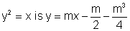is passing through (c,o)
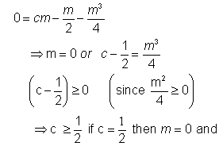
Then only one normal will be there i.e , x axis
Now the slope of other two normal are
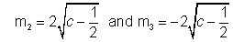
For these normals to be to each other
we need m₂.m₃=-1
so,
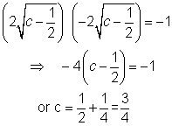
M-3:- Find the equation to the common tangents to the circle x²+y²=2a²
and the parabola y²=8ax.
Ans :-
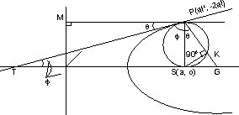
The Equation of any tangent to the parabola y²=8ax i.e,
will touch the circle x²+y²=2a² if
radius =
= length of the perpendicular from the centre(0,0) to the line
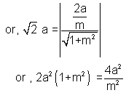
or, m²(1+m²)=2
or, m⁴+m²-2=0
or,(m²+2)(m²-1)=0
But m²+2=0 gives non real values of m.
m²-1=0;
m=
Putting m in (1) we get the equation of common tangents are
the equations of common tangents are.
y = x 2a
or y=x + 2a and y=-(x+2a)
Dumb question : why y= x2a gave only four equations of straight line
y=x+2a & y= -(x+2a) where as four lines are possible?
Ans:- Note that the equation of tangent in y= 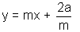
So, it is not possible m with x be +ve and m with 2a be -ve . hence y=x-2a & y=-x+2a are impossible solutions.
Q.7: Prove that the circle circumscribing the triangle formed by tangents to a parabola passes through the focus
Ans: Let P(at₁², 2at₁),q(at₂²,2at₂) and r(at₃²,2at₃) be three points on the parabola y²=4ax
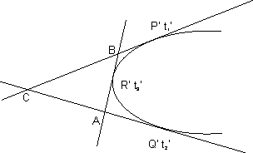
The equation of tangents at P't₁1 and Q't2' are
Y t₁1 = x + at₁²
Y t₂ = x + at₂²
Solving these, x = at₁t₂² and y = a(t₁ + t₂ )
The point of intersection C of the tangents at P and Q is
{ at₁ t₂ , a(t₁ + t₂ )}.
similarly other points of intersection of tangents are
B = {at₃t₁, a(t₃+t₁)},A={at₂t₃,a(t₂+t₃)}
let the equation of circumcircle of the ABC be
x²+y²+2gx+2fy+c=0------------(1)
(1) will pass through the focus (a,0) if
a² + 2ga + c=0..........................(2)
A,B,C are points on (1) .so-
a² t₁² t₂² +a² (t₁+t₂)²+ 2g.at₁t₂+2.f.a(t₁+t₂)+c=0.........(3)
a² t₂² t₃² +a² (t₂+t₃)²+ 2g.at₂t₃+ 2.f.a(t₂+t₃)+c=0...........(4)
a² t₃² t₁² +a² (t₃+t₁)²+ 2g.at₃t₁+ 2.f.a(t₃+t₁)+c=0...........(5)
(3)-(4)
a² t₂²( t₁²-t ₃²+a² (t₁-t₃)(t₁+2t₂ +t₃+2g.at₂(t₁- t₃₎+2.f.a(t₁-t₁)+c=0
or, a² t₂² (t₁+t₃+a²(t₁+2t₂ +t₃2g.at₂t₂+ 2.f.a=0..........(6)
similarly (4)-(5)
=> a²[t₂² (t₁ + t₃) - ₃²(t₂ + t₁) + t₂ - t₃] + 2g.a(t₂ - t₃) = 0
or,a [t₂t₃(t₂ - t₃) + t₁(t₂² - t₃²) + t₂-t₃)] + 2g(t₂-t₃) = 0
or,a[t₂t₃ + (t₁t₂) + t₁t₃ + 1] + 2g=0
2g=-a(1 + t₁t₂ + (t₂t₃) + t₃t₁)
From t₃x(6) - t₂ X(7),we get
2f=-a(t₁ + t₂ + t₃-t₁t₂t₃)
putting values of 2g, 2f in (3) we get
the equation of the circumcircle is-
-
it passes through(a,0) because.-
-
Hence the problem.-
Dumb Question: How does the fact that the circle x²+y²+2gx+2fy+c=0 passes through(a,0) leads to the condition -
a²+2ga+c=0-
Ans:- Since the circle passes through (a,0) the equation of circle must satisfy the point(a,0)-
so, a²+0²+2g(a)+2f(0)+c=0-
0r a²+2ga+c=0 is obtained.-
let c1 and c2 be respectively the parabola x²=y-1 and y^{2=x} p be any point on c1 and q be any point on c2. Let p1 and Q1 be reflections of P and Q-
respectively with respect to the line=y
prove that p1 lies on c2, Q1 lies on c1 and PQ> min[pp1,QQ1]-
Hence or otherwise determine points p₀ and Q _{0 on} the parabolas c1 and c2 respectively. such that p₀Q₀ (Pq)-for all pairs of points (p,Q) with p on c1 and Q on c2.-
Ans:
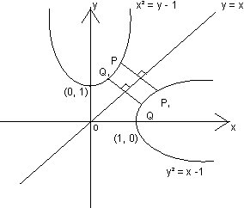
Let co-ordinates of p and q are p(t, t²+1) and Q (s² + 1, s) which lies on x²=y-1
and y²=x-1 respectively.-
p1 and Q1 be reflections of P and Q respectively with respect to the line y=x then-
we have, (PQ₁)²=(t-s)²+(t²-s²)²
(p₁Q)²
=>PQ1=PIQ
Thus PP1QQ1 is an isosceles trapezium
we have Pq> min {PP1,QQ1}
Let us take min {PP1,QQ1}=PP₁
then (PQ)²=(pp₁)²
=>(t ²+1-t)²+(t-t²-1)²=2(t²-t+1)²=f(t)say
we have f'(t)=4(t²-t+1)(2t-1)
NOw 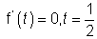
Also 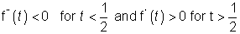
Hence f(t) is least when t=1/2 point p₀ on c1 is 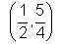and p1(which we take as Q₀
and c2 are 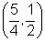.Note that PQ for all pairs of(P,Q) with p on C1 and Q on c2.
Hence proved.
Dumb Question:- f' (t) is4(t²-t+1)(2t-1), but the only solution is t=1/2. what about the factor t²-t+1?
Ans:- Note that t²-t+1=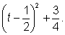
Now, this a positive quantity if t is + ve.
The coordinate plane is a real plane Where the points can take only real values and hence t has to real only. So, t2 - t + 1 cannot be zero.
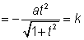=k (from the equation)
from (1) the equation of the axis of the parabola in x,y coordinate becomes-
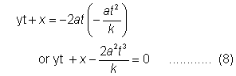
The given parabola is x²=-8k(y-2k)........(9)
solving (8) and (9) we get
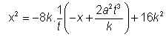
here D= 64k²-64t²(a²t²-k²
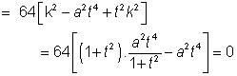
the axis given by(8) touches the given parabola.
Note:- if we take 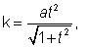, the points of intersection of the axis and the given parabola will be imaginary.
Que:- A parabola drawn touching the axis of x at the origin and having its vertex at a given distance k from the x - axis . Prove that
the axis of parabola is a tangent to the parabola x2 + 8k(y - 2k) = 0.
Ans : Let the equation of the parabola be Y2 = 4ax
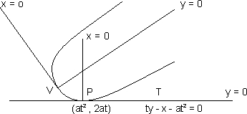
Any tangent to it at the point (at², 2at) is
Yt = X +at².........(1) The normal at the point( at², 2at) is
Y + tX = 2at + at³........(2)
Take the equations of transformation -
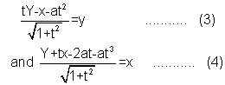
in xy coordinates p=(0,0) and PT is the axis which is
tangent to the parabola at the origin.
Now,
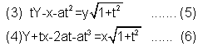
the axis of the parabola(y=0) becomes-
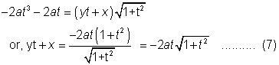
the distance of the vertex v(0,0) in the x,y coordinates from pt -
keywords:-
1. Parabola
2. focus
3. Directrix
4. Eccentricity
5. Vertex
6. Axis.
7. Latus rectum.
8. Diameter
9. Focal distance
10. Focal Chord.

